CHAPTER EIGHT
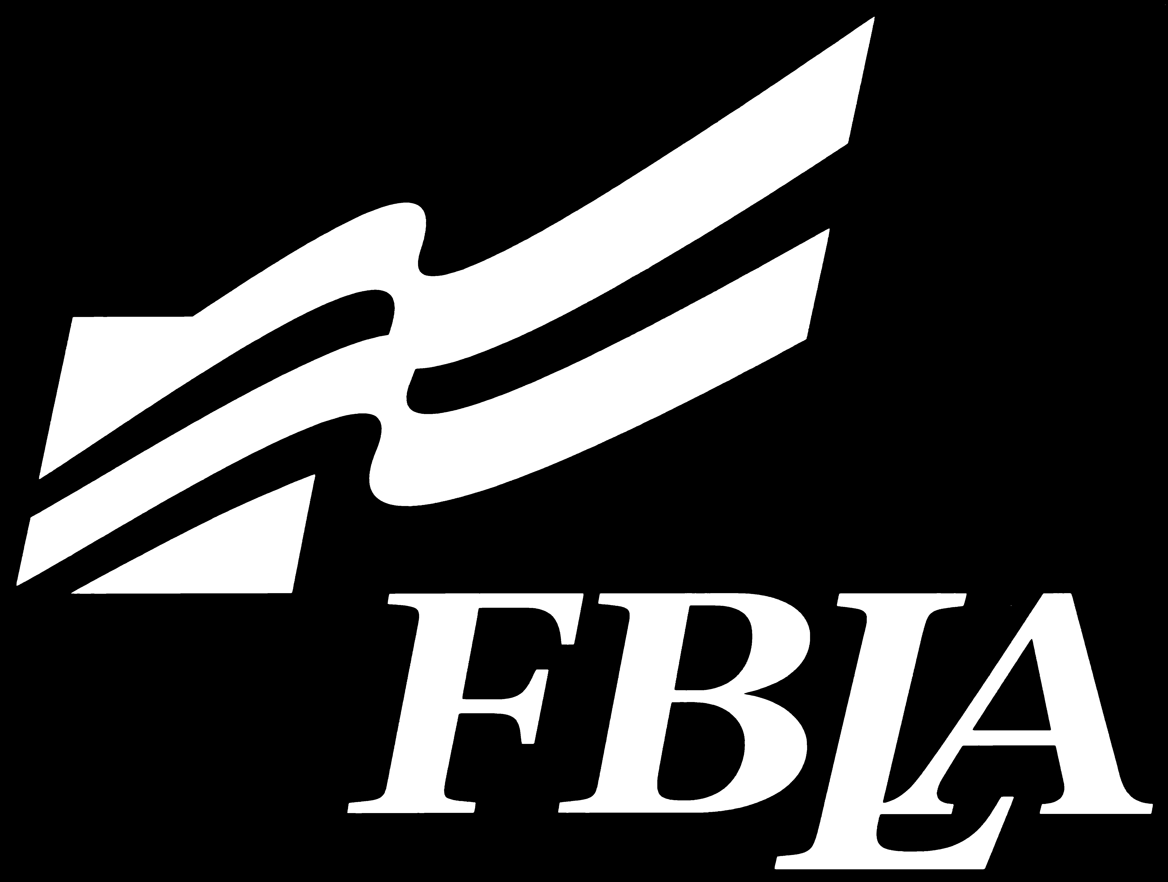

Study Guides

The following study guides are offered an aid to students preparing for competition in FBLA Principles and Procedures and Spelling. Caution: These study guides are not all inclusive–material for events may come from several sources.

Part of the Mr. and Ms. Future Business Leader test will cover FBLA knowledge, so the FBLA Principles and Procedures can be used to study for that part of the test.
STUDY GUIDES
FBLA-MIDDLE LEVEL/JUNIOR HIGH

FBLA Principles and Procedures

- What are the official colors of FBLA? blue and gold
- The FBLA creed contains how many stanzas? seven
- Who is the founder of FBLA? Hamden L. Forkner
- When (year) was the first state chapter chartered? 1947
- In the officer installation ceremony, what color candle represents the chapter in its entirety? White
- The first FBLA chapter was chartered where? Johnson City, Tennessee
- What date was the first FBLA chapter chartered? February 3, 1942
- What year and what group purchased the land for the FBLA-PBL National Center? 1981, Conrad N. Hilton Foundation
- What are the three words across the top of the FBLA emblem? Service, Education, Progress
- Who is the current Arkansas FBLA-PBL State Chairman? Morgan Ruff
- There are currently how many FBLA-Middle Level/Junior High districts in Arkansas? Five
- How many team events are there in FBLA-Middle Level/Junior High district competitive events? Six
- Who is the Arkansas FBLA State Adviser? Morgan Ruff
- In what year was Phi Beta Lambda created? 1958
- What grade levels are eligible for membership in Arkansas FBLA-Middle Level? Grades 5-9
- Who was the first executive director of FBLA-PBL? Dr. Edward Miller
- Who is the Conference Director of FBLA-PBL? Richard Bowen
- Who is the Director of Membership for FBLA-PBL? Lisa Frye Smothers
- Where is the National FBLA-PBL Center located? Reston, Virginia
- Who is the Director of Education for FBLA-PBL? Gayle Robinson
- In what year was the groundbreaking for the National Center held? 1990
- What year was the Professional Division created? 1989
- In the absence of the president and vice-president at a regular meeting, who should call the meeting to order? Secretary
- What symbol on the emblem denotes our belief in democracy, liberty, and the American way of life? Eagle
- What body is the policy making body for national FBLA-PBL, Inc.? National Board of Directors
- What do the initials NBEA stand for? National Business Education Association
- What are the four divisions of FBLA-PBL? FBLA-Middle Level, FBLA, PBL, and Professional Division

- Where was the first chapter of FBLA in Arkansas? Fort Smith High School
- How is FBLA-PBL, Inc. primarily funded? Membership dues
- According to the Arkansas FBLA-Middle Level/Junior High bylaws, who may be a FBLA chapter adviser? Faculty member of a business department
- The largest room at the National Center is the Conference room. It was a gift from what state? Arkansas
- What do the initials USDE stand for? United States Department of Education
- What are the grants given by the March of Dimes program that are designed to reward members and chapters for their support of March of Dimes? Mission LIFT Grants
- What do the initials LIFT in Mission LIFT stand for? Leading Into the Future Together
- What is the name of the national publication for FBLA and FBLA-Middle Level members? Tomorrow’s Business Leader
- What is the national publication for FBLA and FBLA-Middle level advisers called? Hotline
- What is the name of the publication that each local chapter receives that contains all the information about FBLA – national constitution and bylaws, national programs, national organization, etc.? Chapter Management Handbook
- What is the national program called that encourages chapters from all divisions to team up to leverage their potential for success? Connecting Chapters
- The national recognition program that recognizes FBLA members who recruit at least four (4) new members is called? Night of the”Body Snatchers” II
- The national recognition program that recognizes local FBLA chapters who either maintain or increase their local chapter membership over last year’s total? Membership Achievement Award
- What is meant by the statement that FBLA-PBL membership is unified? Must be a member at local, state, and national levels
- What are the dates of National FBLA-PBL week? Second week in February
- Which officer presides over and conducts meetings according to Parliamentary Procedure? President
- When is a local chapter considered inactive? After failing to pay dues for one year
- What is another name for a written plan of action? Program of Work
- What year was Arkansas FBLA established? 1954
- What year was the first junior high district in Arkansas established? 1978
- What color of candle symbolizes the office of president? Red
- There are how many FBLA-Middle Level goals? Eight
- The national dues for FBLA-Middle Level are how much annually? $6.00
- Excluding the three division presidents, what is the term of office for National Board of Director members? Three years
- Who is the FBLA-PBL President and CEO? Alexander T Graham
- Who is the FBLA-PBL Communications Manager? Evan Dean
- What officer counts the votes and then records them during an election? Secretary
- In the officer installation ceremony, what color candle symbolizes office of reporter? Violet

- Who determines national dues? National Board of Directors
- How much are Arkansas FBLA-Middle Level/Junior High dues? $2.00
- Which month is National Education for Business month? November
- What is the year of the dedication/grand opening of the FBLA-PBL National Center? 1991

- What is the official parliamentary procedure reference record for FBLA? Robert’s Rules of Order, Newly Revised
- What does the initials NASSP stand for? National Association of Secondary School Principals
- A community service project that focuses FBLA-PBL members on practicing leadership and management skills they have learned to raise funds and awareness for the March of Dimes. Mission LIFT
- Who needs to approve a new chapter application before it is forwarded to the National office? State chairman
- How many administrative regions does National FBLA-PBL have? Five
- How long does the FBLA-PBL Board of Directors Chairman serve in that office? One year
- What year did FBLA gain independent status? 1969
- What year was FBLA-Middle Level division established at the national level? 1994
- When is American Enterprise Day observed each year? November 15
- FBLA-PBL Week is planned every February to coincide with what other celebration? National Career and Technical Education Week
- The parliamentary procedure term to close the meeting when no motion is pending and there is no further business is called? adjourn
- The national event that recognizes FBLA-Middle Level chapters that successfully implement a project to serve the citizens of their community. Community Service Project
- The national chapter recognition program that recognizes chapters who complete 10 of 13 activities listed on the entry form. This award recognized chapters who go above and beyond in their FBLA-PBL participation. Chapter Excellence Award
- What FBLA national administrative region is Arkansas located in? Southern
- What officer should appoint the committee chairman? President
- A question directed to the presiding officer to obtain clarification on a parliamentary law or the rules of the organization bearing on the business at hand is called? Parliamentary inquiry
- The individual recognition award where members must complete 10 of 13 activities three different sections of the entry form. LEAD Explore Award
- What is the short intermission in a business meeting called? Recess
- Arkansas service project that educates people about the importance of organ donation. Gift of Life (ARORA)
- What is the national recognition program that recognizes local chapters who recruit 100% of a single course as chapter members called? 100% Class Participation Award

- The national recognition award that goes to the local chapter that has the largest chapter member based on the percentage of school enrollment? Market Share Award
- What is the national award called that is given to those local chapters that charter or reactivate the most chapters of FBLA-Middle Level, FBLA, or PBL. Local Recruitment of Chapters
- Which officer is prepared to explain any irregularity and its effect on the rights of all chapter members? Parliamentarian
- The individual recognition award where members must complete 12 of 16 activities from three sections on the entry form? LEAD Aspire Award
- What state became FBLA’s first state chapter? Iowa
- How many local chapters must a state have to be issued a state charter? Five
- What is the parliamentary procedure term to suggest names to be considered for office? Nominate
- The year national FBLA-PBL membership topped the 200,000 mark for the first time? 1987
- What organization sponsored FBLA before it gained its independent status? National Council for Business Education (now known as National Business Education Association–NBEA)
- In what year was the National Center Mortgage retired? 2001
- Who was the first state president of Arkansas FBLA? Dorothy Frazier
- What is the last sentence of the creed? “I promise to use my abilities to make the world a better place for everyone.”
- What is the national event that recognizes FBLA-Middle Level chapters that successfully implement an education program to promote free enterprise? American Enterprise Project
- The national program that allows FBLA members to invest a hypothetical $100,000 in NASDAQ, AMEX, and NYSE-listed common stock is called? Stock Market Game
- What is the official source for National FBLA materials such as t-shirts, officer pins, plaques, and other gift items? The Marketplace
- In the officer installation ceremony, what color candle symbolizes the office of treasurer? Blue
- What is the membership year of FBLA-Middle Level? July 1 - June 30
- In the absence of the president at a chapter meeting, which officer serves as the presiding officer? Vice President
- What is the parliamentary term for the discussion of the merits of a motion? Debate
- In a chapter meeting, if you want to change the wording of a motion that is being discussed, what do you have to do? Make a motion to amend the main motion
- Chapter activities fall into five functional areas, name them. Professional Development, Civic, Service, Social, and Financial

