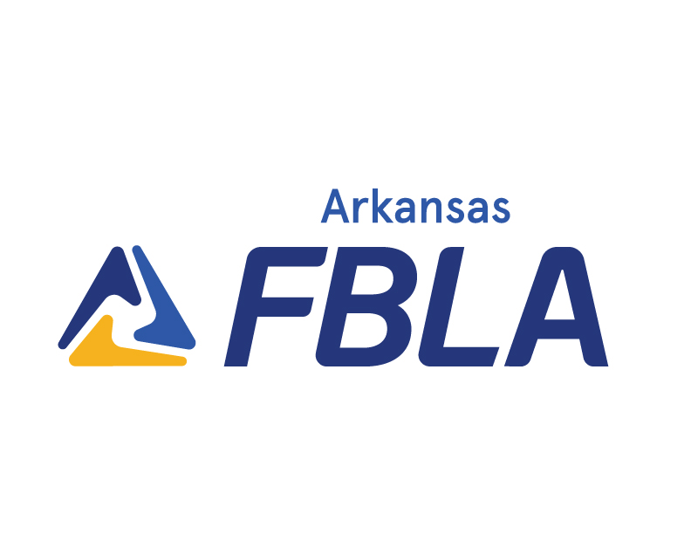**ARKANSAS**

**FUTURE**

**BUSINESS**

**LEADERS OF**

**AMERICA**

**MID-LEVEL**

**State Handbook**

**2024-2025**

**Revised October 2024**



# District Officers

## Election of District Officers

The election of five district officers: President, Vice President, Secretary, Treasurer, and Reporter, is held at the District Spring Leadership Conferences. Any member is eligible to run for district office with approval of the local chapter adviser.

Each local chapter may run one candidate for one office. Applications must be submitted by the stated deadline stated in the Spring Leadership Conference packet. If an office remains unfilled, chapters will be notified and applications will be taken or officers may be appointed.

If a student is elected, he/she and their advisor shall be required to attend a District Officer Training in the summer.

## Duties of District Officers

PRESIDENT Presides at all meetings including Executive Council meetings; promotes the growth and development of the association.

VICE PRESIDENT Accepts the responsibilities of the president as occasion may demand; promotes the growth and development of the association.

SECRETARY Records the proceedings of all business and Executive Council meetings; accumulates the minutes and/or proceedings of all meetings and conferences and presents the accumulated records to the newly elected secretary at the Spring Leadership Conference; promotes the growth and development of the association.

TREASURER Presents any financial and membership records necessary and submits to the Secretary for inclusion in the minutes; promotes the growth and development of the association; handles details of registration at the district conferences.

REPORTER Works closely with the president and Executive Council to encourage maximum publicity by all chapters; accepts the responsibility of producing two issues of the district newsletter annual; promotes the growth and development of the association.



# Conferences

## Dress Code for Conferences

The leadership conferences attended by Arkansas FBLA-Middle School/Junior High members are

designed to train students to become leaders in business. Part of that training is teaching students to

wear appropriate business attire for these meetings. Because the organization is of a business

nature, it is fitting that students dress to portray the business image of the organization. This image is a reflection on individual schools and FBLA.

The following dress code has been adopted by the State Executive Council and approved by the State FBLA-PBL Board of Directors:

**General Sessions, Competitive Events, and Workshop Sessions.**

Business attire for young women must be a business suit, appropriate dress, or professional pants suit. Many women’s two-piece suites are designed so that they do not require a blouse; therefore, this will be accepted. Outfits of denim (any color) are not allowed. Shoes for women should be dress. No tennis shoes or athletic shoes are allowed. Sling-back shoes and open toe shoes are accepted. Young men must wear dress slacks (no denim of any color), dress shirt, tie, and dress shoes (athletic or tennis shoes are not appropriate).

The following items are not considered appropriate at any time on an FBLA trip: athletic shorts, spandex, cut-off shorts, bare midriffs, jeans or shorts with frayed holes, t-shirts with suggestive print, muscle t-shirts, or spaghetti strap tops.

## Conferences

**District Fall Leadership Conference**

The Middle School/junior high districts within the state organization hold Fall Leadership Conferences for members of chapters within their geographic boundaries. Students and advisers have an opportunity to share ideas and participate in professional development and chapter building workshops. These district fall conferences are held in September, October or November of each year. Information about the conference and registration information is distributed to each local chapter by the district coordinator.

**District Spring Leadership Conference**

Each Middle School/junior high district has a Spring Leadership Conference in late January or early February. The purpose of these conferences is to further leadership development by participation in the Middle School/junior high competitive events program. Each local chapter will receive information from their district coordinator in early January giving the information about the conference. The conferences are under the direction of the junior high district coordinators and district officers in those districts large enough for officers. In the other districts, the conference is under the direction of the district coordinator and a local chapter’s officers serving as the host school.

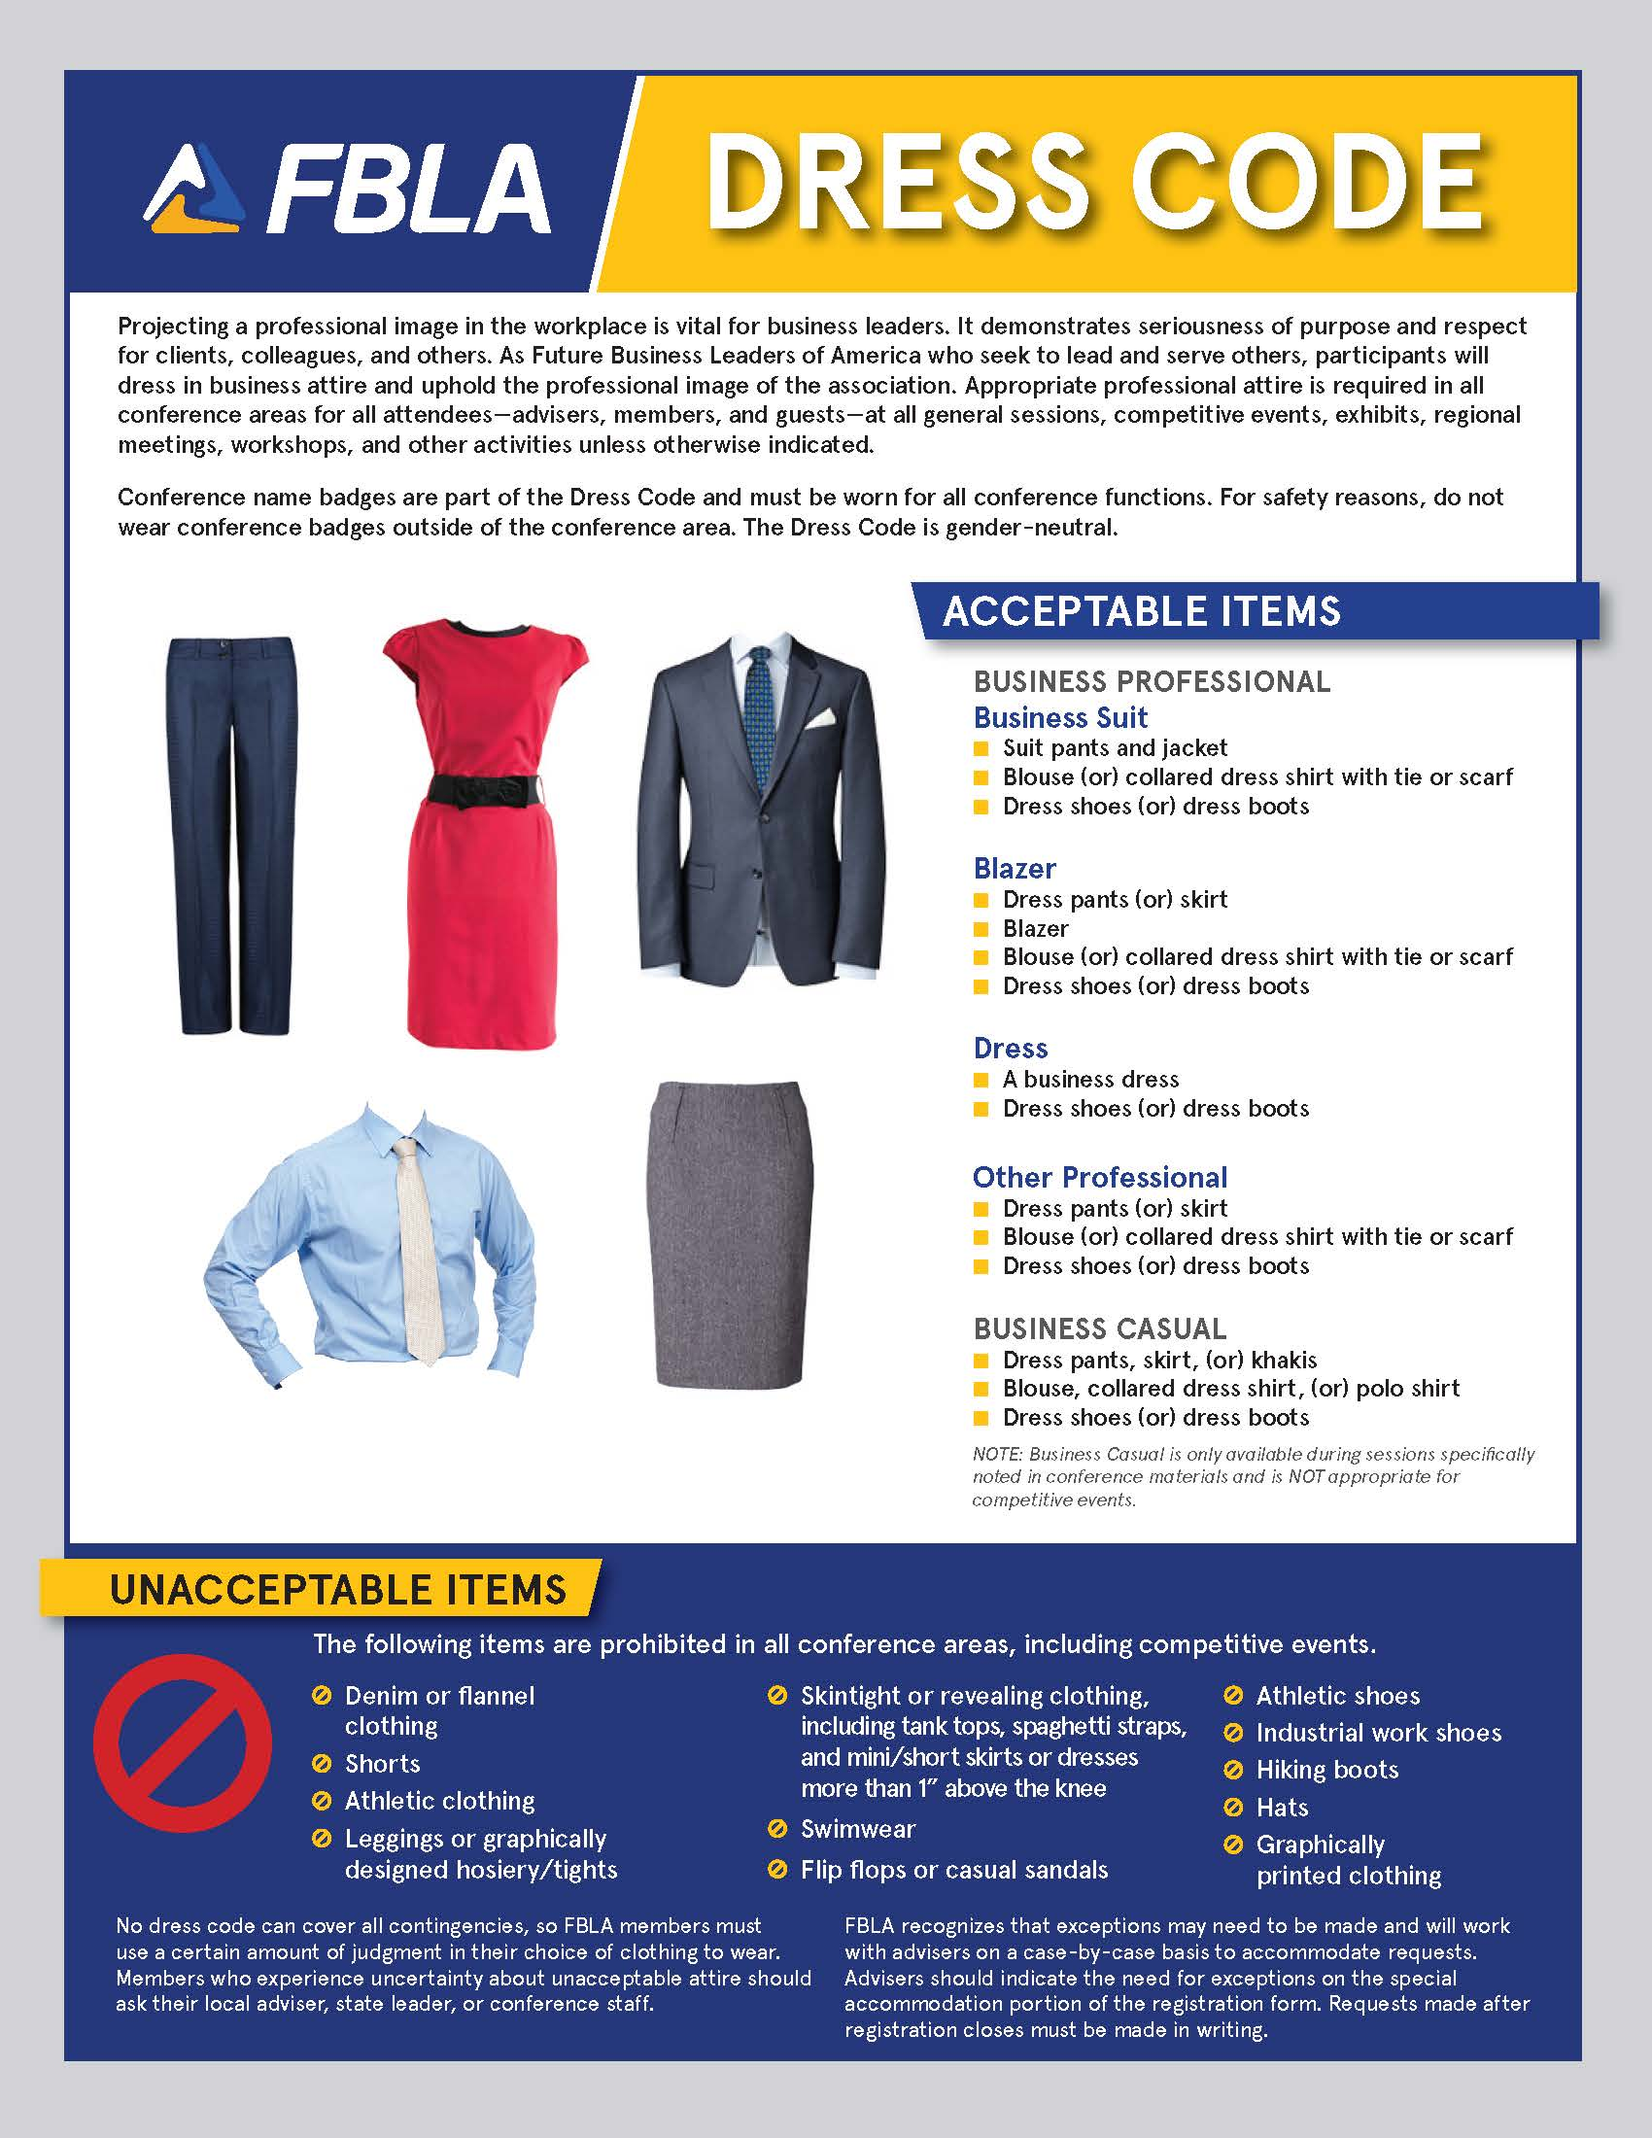



# National Competitive Recognition

The FBLA Middle School Division has implemented new events for National Competitive Recognition. Some events will be recognized as state and district events. To be eligible for competition, the local chapter submitting projects must be registered for their district conference and the members entered in the individual events must be registered for their district conference. They are identified below:

## State/National Event List

|  |  |
| --- | --- |
| **State/National (Objective Event)**   * Business Etiquette * Career Exploration * Digital Citizenship * Exploring Computer Science * Exploring Leadership * Exploring Parliamentary Procedure * Exploring Technology * FBLA Concepts * Financial Literacy * Interpersonal Communication * Learning Strategies | **State/National (Performance Event)**   * Annual Chapter Activities Presentation * Career Research * Community Service Project * Critical Thinking * Exploring Business Ethics * Exploring Business Issues * Exploring Public Speaking * Exploring Website Design * FBLA Mission & Pledge * Marketing Mix Challenge * Video Game Challenge |
| **State/National (Production Event)**   * Exploring Computer Applications | **State (Chapter Event)**   * Outstanding Middle School Adviser * Outstanding Middle School Member |

### [For all State/National Events—Refer to National Website for Description, Topics, Procedures, etc.](https://www.fbla.org/divisions/fbla-middle-level/competitive-events/)

### Event Types

**Objective & Production (State/National)**–These events will involve school-based testing. Testing will be completed by a local school proctor that is **not** an FBLA adviser or member of the business department faculty. The rules governing the school-based testing will follow the same regulations as those already established for district competition. The top five for each event will be recognized at the District Spring Leadership Conferences. State placement will be presented at the Middle School State Leadership Conference. The top entry in the state will be invited to compete at the National Leadership Conference.

**Performance Events (State/National)**– The top 3 for each district will compete at the Middle School State Leadership Conference. The other events will take place at the Middle School State Leadership Conference location and the state placement will be presented. The top entry in the state will be invited to compete at the National Leadership Conference.



# District Awards Program

## General Information

The District Awards Program (DAP) at the District Leadership conferences exemplifies the range of activities and focus of FBLA-Middle School/Junior High. These events are based on projects developed from one of the goals of FBLA-PBL and the curriculum of business education programs.

* Competitors must meet Arkansas Activities Association eligibility requirements.
* **A member may enter up to two individual/team events. However, a student cannot compete in more than one performance event.**
* **A chapter may enter up to 3 members for objective and production events.**
* **A chapter may only enter 1 member for performance events.**
* Members who have won 1-10th place in an event at a previous National Leadership Conference may not enter that event again.
* Reference manuals, textbooks, and other source materials except those listed in the guidelines, **MAY NOT** be taken to the events.
* Members whose dues are received in the national office on or before **January 1** are eligible to participate in competitive events. Membership in FBLA is unified on the local, state, and national levels and is not available separately.

Awards are given to the first five places in each event.

## Mission Statement

**Middle School/Junior High FBLA District Awards Program**

Competitive spirit and recognition of excellence reflect important aspects of the educational process that prepares students for their roles in the American enterprise system.

Today’s students demand and deserve learning experiences that enable them to achieve success through effective participation in career-related activities designed to reach professional goals. The Middle School/Junior High District Awards Program offers this opportunity by providing support for curriculum development, facilitates practical application, and increases conceptual knowledge of business principles.

## Arkansas Activities Association (AAA) Eligibility

Students entered in competitive events must meet the following Arkansas Activities Association eligibility requirements. The AAA has three criteria that must be met for eligibility of vocational students to **compete** in an **interscholastic** event:

* The student must be a bonafide student of the school they represent. (A bonafide student is one who has not graduated from high school and who is enrolled in and attending at least four academic courses identified in the Arkansas Department of Education Standards of Accreditation.)
* The student must meet the scholarship rule.
* The student may not participate after his/her sixteenth birthday.

**AAA Scholarship Rule/Regulation**

Regulations on participation by students in interscholastic activities are:

1. A student promoted from the sixth to the seventh grade automatically meets scholarship requirements.

2. A student promoted from the seventh to the eighth grade automatically meets scholarship requirements for the first semester.

3. The second semester eighth and the first semester ninth grade student meets scholarship requirements for junior high if he/she has successfully passed four (4) academic courses the previous semester, three (3) of which shall be in the core curriculum areas specified by the Arkansas Department of Education’s Standards for Accreditation of Arkansas Public Schools.

4. First semester ninth grade students must pass four academic classes to be eligible the second semester of the ninth grade.

Before entering students in district competition, the adviser must:

1. Verify with school counselor and/or school office that students meet the scholarship regulations as required by the State Board of Education and Arkansas Activities Association.

2. Submit a Certificate of Eligibility for Non-Athletics, signed by the school administrator and the adviser, verifying the eligibility of participation for all the chapter’s contestants.

## District Competitive Events

The following is a list of competitive events offered at the Middle School/junior high district spring conferences:

|  |
| --- |
| **District (Chapter Event)**   * Largest Local Chapter * Largest Local Chapter – Market Share |
|
| **District (Objective Event)**   * Computer Concepts * Introduction to Business Communications * Proofreading * Spelling |
| **District (Production Event)**   * 1’ Minute Timed Typing * 3’ Minute Timed Typing * Business Graphics * Business Reports * Spreadsheets * Tables |
| **District (Performance Event)**   * Job Interview * Mr./Ms. Jr. High Future Business Leader *\*objective test also* |

### Event Types

**Chapter Project**–This is a report that must be completed and submitted to the state office by stated deadline. All of these awards will be presented at the District Spring Leadership Conferences.

**Objective & Production (District)**–These events will involve school-based testing. Testing will be completed by a local school proctor that is **not** an FBLA adviser or member of the business department faculty. The rules governing the school-based testing will follow the same regulations as those already established for district competition (see below). The top five in each event will receive district recognition. All of these awards will be presented at the District Spring Leadership Conferences.

**Performance Events (District)**–These events will take place at the District Spring Leadership Conference location. The top five will be recognized at the District Spring Conference. The top 3 in the district for state events will advance to state competition.

### School Site Testing Procedures—Production/Skills Events

Production/skills tests are administrated prior to the district conference using the School-Site Testing procedure outlined below:

1. Each local chapter must secure a local school district person to administer the skill tests for their contestants. A member of the business department faculty or FBLA adviser may not be the administrator.
2. FBLA advisers and other business department faculty may not handle, see, or be present in the classroom when tests are administered.
3. The tests will be sent directly to the designated test administrator and must stay in the possession of the administrator at all times. The test administrator will be responsible for packaging the tests and returning all testing material to the designated person.
4. A statement of certification must be signed by the test administrator and contestant verifying that copies of the test were not duplicated, saved to hard drive, or extra copies of the contestant’s papers were not printed.
5. Additionally, the test administrator must sign a form verifying that the tests remained in his/her possession the entire time and were not seen by the FBLA adviser or members of the business department faculty.

### School Site Testing Procedures—Objective Test Events

1. Each local chapter must secure a local school district person to administer the objective tests for their contestants. A member of the business department faculty or FBLA adviser may not be the administrator.
2. FBLA advisers and other business department faculty may not handle, see, or be present in the classroom when tests are administered.
3. The testing instructions will be sent directly to the designated test administrator and must stay in the possession of the administrator at all times.
4. Competitors will receive tickets for access to the online testing system.

## Event Guidelines

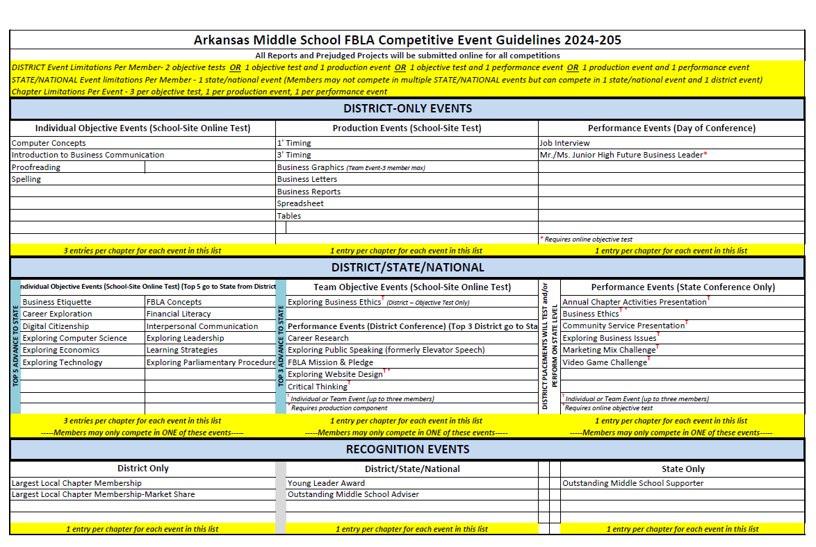

## Largest Local Chapter Membership

Effective district, state, and national programs depend upon membership support and growth. Increased membership provides resources for the expansion of services to local chapters. Membership recruitment offers a worthwhile experience in public relations and leadership. Recognition is given to those local chapters who have attained the largest membership in Middle School/Junior High FBLA.

**Eligibility**

All active local chapters are eligible.

**Procedure**

Official membership records are audited by the district coordinator; therefore, no entry form is required for this event.

Winners in this event are determined by the district coordinator. The figures used in determining the winners will be the number of paid FBLA members on record in the state and national offices as of January 1 of the current school year.

**Awards**

The top five winners from each district will be recognized by the district and the individuals will receive a plaque for first place and certificates for second through fifth places. **To be eligible for a district award, contestants must be registered in the online registration program by stated deadline in District Conference packet and pay the district registration fee.**

## Largest Local Chapter Membership - Market Share

This event is designed to encourage chapters from small schools to compete in the FBLA membership awards. This event also seeks to promote active membership recruitment on a competitive basis for all schools and provide additional recognition to those chapters and members who have actively promoted the growth of FBLA.

**Eligibility**

All active chapters are eligible to submit one entry form.

**Regulations**

1. The official membership figures used in this event will be determined by a percentage of FBLA membership from the **total student body enrollment**.
2. The entry form must be received by the district coordinator by the deadline stated in the District Spring Leadership Conference packet.

The official entry form is provided. A copy of the form should be submitted for competition.

**Judging**

Judging will be based on percentage of FBLA membership from the **total student body enrollment**. The percentage is calculated on total student body enrollment of each grade where members are eligible for FBLA membership.

Winners in this event are determined by the district coordinator after the membership audit of state and national records as of January 1 of the current year.

**Awards**

The top five winners from each district will be recognized by the district and the individuals will receive a plaque for first place and certificates for second through fifth places. **To be eligible for a district award, contestants must be registered in the online registration program by stated deadline in District Conference packet and pay the district registration fee.**

## Business Graphics

This event is designed to recognize FBLA members who demonstrate the ability to design graphic layouts using their creative abilities in this field.

**Eligibility**

Each local chapter may enter an individual or a team of up to three participants who are on record in the state and national office as paying dues by January 1 of the current school year.

**Regulations**

1. The participants must be registered online by the deadline stated in the District Spring Leadership Conference packet.
2. The participant must be selected in accordance with the regulations of the state chapter.
3. Participants failing to report on time for the event may be disqualified.
4. A Statement of Assurance form must be filled out for entry to this event.

**Procedure**

1. Forty-five (45) minutes will be allowed for this event.
2. Participants will be given a theme relating to FBLA at the beginning of the event. All work must be done by the participants within this time period. The actual event will take place at the school testing site. Competitors must use some type of image editing software to create their original illustration. Once completed, each image should be saved as a PDF or JPEG for judging purposes. Failure to do so may result in submission not being judged.

**Judging**

Images will be graded by a panel of judges. All judges’ decisions are final.

**Awards**

The top five winners from each district will be recognized by the district and the individuals will receive a plaque for first place and certificates for second through fifth places. **To be eligible for a district award, contestants must be registered in the online registration program by stated deadline in District Conference packet and pay the district registration fee.**

**Business Graphics**

### Rating Sheet

Points given may range between zero and maximum number indicated.

**Theme**

Relation to theme and FBLA _______ 40

**Arrangement**

Eye appeal

Art principles considered _______ 20

**Copy**

Appropriate use of words _______ 10

**Neatness**

_______ 10

**Presentation**

Applicability for use in promoting FBLA _______ 20

**Score __________ 100**

**NAME OF SCHOOL ___________________________________________________________**

**TEAM MEMBERS**

**JUDGE’S COMMENTS:**

## Business Letters

Keying skills are primary requisites for obtaining positions in business. This event is designed to recognize FBLA members who display skills in keying business letters.

**Eligibility**

Participants must be on record in the state and national offices as paying dues by January 1 of the current school year.

**Regulations**

1. The participants must be registered online by the deadline stated in the District Spring Leadership Conference packet.
2. The participant must be selected in accordance with the regulations of the state chapter.
3. Participants failing to report on time for the event may be disqualified.
4. A Statement of Assurance form must be filled out for entry to this event.

**Procedure**

**School-Site Testing**

1. Forty-five (45) minutes will be allowed for the skills test at the school testing site. Additional time will be allowed for general directions, equipment set up, and warm-up. Problems are weighted according to difficulty and may be completed in any order.
2. Results will be based on mailable copy. Material that could be considered mailable with slight or serious corrections will receive reduced credit. Participants will save as they go and submit the files online in accordance with the given instructions.
3. Participants must recognize the necessity for accurate proofreading.
4. Word division manuals and dictionaries may be used as reference materials.

**Judging**

Judging of skills tests will be based on printed copy using the Standards of Mailability on the national FBLA website. The documents will be scored by a panel of judges for this event. All decisions of the judges are final.

**Awards**

The top five winners from each district will be recognized by the district and the individuals will receive a plaque for first place and certificates for second through fifth places. **To be eligible for a district award, contestants must be registered in the online registration program by stated deadline in District Conference packet and pay the district registration fee.**

## Computer Concepts

The handling of data is important in the operation of a business. This event is designed to provide recognition for FBLA members who understand the basic principles involved in computer systems.

**Eligibility**

Participants must be on record in the state and national offices as paying dues by January 1 of the current school year.

**Regulations**

The participant must register online by the deadline stated in the District Spring Leadership Conference packet.

**Procedure**

* A 30-minute objective test will be administered at the school testing site.
  + School-site testing will take place online.

**Judging**

The test will be graded by the online grading program. Ties will be broken based on the last ten questions. In the event there is still a tie, the time the test was completed online in will be the deciding factor. All judges’ decisions are final.

**Awards**

The top five winners from each district will be recognized by the district and the individuals will receive a plaque for first place and certificates for second through fifth places. **To be eligible for a district award, contestants must be registered in the online registration program by stated deadline in District Conference packet and pay the district registration fee.**

## Introduction to Business Communications

The ability to proofread work accurately is a valuable business tool. This event is designed to provide recognition for Middle School FBLA members who have learned basic proofreading techniques, the ability to proofread accurately, spelling, and basic grammar rules.

**Business Education Curriculum Standards:**

Communications

**Eligibility**

Participants must be on record in the state and national offices as paying dues by January 1 of the current school year.

**Regulations**

The participant must register online by the deadline stated in the District Spring Leadership Conference packet.

**Procedure**

Participants will be given a forty-five (30) minute online objective test which may include questions on proofreading, grammar, punctuation, word division, expression of numbers, capitalization, and business spelling.

**Judging**

The test will be graded by the online grading program. Ties will be broken based on the last ten questions. In the event there is still a tie, the time the test was completed online in will be the deciding factor. All judges’ decisions are final.

**Awards**

The top five winners from each district will be recognized by the district and the individuals will receive a plaque for first place and certificates for second through fifth places. **To be eligible for a district award, contestants must be registered in the online registration program by stated deadline in District Conference packet and pay the district registration fee.**

## Job Interview

Interviewing skills are primary requisites for obtaining positions in business. This event is designed to recognize FBLA members who demonstrate skill in completing an application, preparing a resume, and interviewing.

**Eligibility**

Each chapter may enter one contestant. Participant must be on record in the state and national offices as paying dues by January 1 of the current school year. This event is restricted to grades 7-9.

**Regulations**

1. The participant must be registered online by the district coordinator by the deadline stated in the District Spring Leadership Conference packet.
2. Three copies of the resume must be submitted to the district coordinator by the deadlines stated in the conference packet. Resume should include the following headings **in this order**:
3. Personal information to include name, address and phone number. E-mail is optional.
4. Career objectives
5. Educational background-school name, grade point average, business courses
6. Extracurricular activities
7. Honors and achievements

***NOTE: Participants failing to submit their resumes by the stated deadline will not be eligible to compete in this event.***

1. The participant must be selected in accordance with the regulations of the state chapter.
2. Advisers must report to the events confirmation desk at the District Leadership Conference to verify event registration.
3. Participants failing to report on time for the event may be disqualified.

**Procedure**

1. If an online application was not provided by the district coordinator, all participants will meet together prior to the interview to complete their job application (in ink). The application form may include a short writing exercise.
2. Participants will be able to select from the following job descriptions for his/her resume/application form. Participant should research one of the following jobs and be prepared to discuss the job qualifications in the interview portion of this event.

• Secretary Computer • Programmer

• File Clerk • Graphics Specialist

• Receptionist • Manager Trainee

• Computer Specialist • Word Processor

• Data Entry Clerk • Accounting Clerk

1. Participants must furnish their own pens and correction materials.
2. Fifteen (15) minutes will be allowed to complete the application.
3. As participants complete their application, they will be given their interview time.

**Judging**

There will be a panel of judges for this event. All judges’ decisions are final.

**Awards**

The top five winners from each district will be recognized by the district and the individuals will receive a plaque for first place and certificates for second through fifth places. **To be eligible for a district award, contestants must be registered in the online registration program by stated deadline in District Conference packet and pay the district registration fee.**

### Rating Sheet for Job Interview

Points given may range between zero and maximum number indicated.

**Application Form and Resume**

Clear and concise presentation of facts

according to the guidelines _______ 10

Correct grammar, punctuation, spelling,

and acceptable business style _______ 10

Evidence of skills for business _______ 10 _______ 30

**Interview**

Poise and maturity _______ 5

Self-Confidence, initiative, and

assertiveness _______ 5

Communication skills _______ 10

Presentation of facts in an orderly

manner _______ 5

Personal appearance (grooming and

appropriate business attire) _______ 10 _______ 35

**Leadership Ability**

Participation in extra-curricular

activities _______ 10

Leadership role _______ 5

Participation in school and/or

community organizations _______ 5

Demonstration of outstanding

achievement _______ 5

Career knowledge and career plans _______ 10 _______ 35

**Interview Score ______100**

**Total Points Deducted _______**

**Final Interview Score _______**

**NAME _________________________ SCHOOL**

**JUDGE’S SIGNATURE**

**COMMENTS:**

## Business Reports

This event is designed to recognize FBLA members who demonstrate skill in keying simple manuscripts.

**Eligibility**

Each local chapter may submit one entry. Entries must be an individual member. Participants must be members of an active local Middle School chapter who are on record in the FBLA-PBL National Center as having paid dues by January 1 of the current school year.

All Middle School FBLA members in grades 5 through 9 are eligible for this event.

**Regulations**

1. The participants must be registered online by the deadline stated in the District Spring Leadership Conference packet.
2. The participant must be selected in accordance with the regulations of the state chapter.
3. Participants failing to report on time for the event may be disqualified.
4. A Statement of Assurance form must be filled out for entry to this event.

**Procedure**

**School-Site Testing**

1. Forty-five (45) minutes will be allowed for the skills test at the school testing site. Additional time will be allowed for general directions, equipment set up, and warm-up. Problems are weighted according to difficulty and may be completed in any order.
2. Results will be based on mailable copy. Material that could be considered mailable with slight or serious corrections will receive reduced credit. (Refer to the Standards of Mailability on the national FBLA website.) Participants will save as they go and submit the files online in accordance with the given instructions.
3. Participants must recognize the necessity for accurate proofreading.
4. Word division manuals and dictionaries may be used as reference materials.

**Judging**

Judging of the skill tests will be by a panel of judges using the standards of mailability. All decisions of the judges are final.

**Awards**

The top five winners from each district will be recognized by the district and the individuals will receive a plaque for first place and certificates for second through fifth places. **To be eligible for a district award, contestants must be registered in the online registration program by stated deadline in District Conference packet and pay the district registration fee. No additional testing will be administered at the district conference**

## Mr. and Ms. Jr. High Future Business Leader

These events are designed to provide recognition to outstanding Junior High FBLA members who have demonstrated leadership qualities, participation, and interest in FBLA.

**Eligibility**

Each local chapter may enter one participant in each event. Participants must be on record in the state and national offices as paying dues by January 1 of the current school year. These events are restricted to grades 7-9.

**Regulations**

1. The participant must register online for the event and take an objective test by the stated deadline in the District Conference packet.
2. The participant must be selected in accordance with the regulations of the state chapter.
3. Advisers must report to the events confirmation desk at the conference to verify event registration.
4. Participants failing to report on time for the event may be disqualified.
5. The contestants with the top designated scores on the written online objective test will be interviewed at the District Spring Leadership Conference by a panel of judges. (The number to be interviewed will vary from district to district—the designated number can be found in the District Spring Leadership Conference packet.)
6. Three copies of the resume must be submitted to the district coordinator by the deadlines stated in the conference packet. Resume should include the following headings **in this order**:
   1. Personal information to include name, address and phone number. E-mail is optional.
   2. Career objectives
   3. Educational background-school name, grade point average, business courses
   4. FBLA involvement-for example: conferences attended, leadership roles, school & community involvement
   5. Extracurricular activities
   6. Honors and achievements

**NOTE: Participants failing to submit their resumes by the stated deadline will not be eligible to enter this event.**

1. Judges must deduct one (1) to fifteen (15) points from the interview score of participants who submit materials by the stated deadline, but do not adhere to the event guidelines for the submission of proper materials.
2. Advisers should serve as consultants to ensure that the resume is well organized, contains substantiated statements, and is written in a business style.

**Procedure**

These events consist of two parts: a 30 minute online objective test is taken as a school-site test and the interview is conducted at the conference site.

**Objective Test**

Participants will be given an online objective test designed to measure their knowledge of FBLA and business concepts. The test may include questions on general information about FBLA-PBL history, business concepts (basic business); business mathematics, business English, parliamentary procedure, and general knowledge of business activities.

**Mr. And Ms. Jr. High Future Business Leader Page 2**

**Interview**–The top contestants (number varies per district) with the highest test score will be scheduled for an interview. A weighting of 50 percent interview score and 50 percent objective test score will determine the top five winners.

**Judging**

All objective on-line tests are graded by the program. In the event of ties in determining the top [participants to interview, scores associated with the objective test portion of the event will be used to break the ties. The program evaluates the last ten (10) questions from the test and the student missing the least number of questions on the last 10 questions will be ranked accordingly. The on-line tests constitutes 50 percent of the final event score.

There will be a panel of judges for the interview portion of these events. In case of a tie, the interview process will be used to determine the final rank. All judges’ decisions are final.

**Awards**

The top five winners from each district will be recognized by the district and the individuals will receive a plaque for first place and certificates for second through fifth places. **To be eligible for a district award, contestants must be registered in the online registration program by stated deadline in District Conference packet and pay the district registration fee. No additional testing will be administered at the district conference.**

**Mr./Ms. Jr. High Future Business Leader Interview**

### Rating Sheet

Points given may range between zero and maximum number indicated.

**Resume**

Clear and concise presentation of facts

with logical arrangement _______ 10

Correct grammar, punctuation, spelling,

and acceptable business style _______ 10

Evidence of participation in FBLA and

skills for business _______ 10 _________ 30

**Interview**

Poise and maturity _______ 5

Self-confidence, initiative, and

assertiveness _______ 5

Communication skills _______ 10

Presentation of facts in an orderly manner _______ 10

Personal appearance (grooming and

appropriate business attire) ________ 5 _________ 35

**Leadership Ability**

Participation in and knowledge of FBLA _______ 10

Leadership Role in FBLA _______ 5

Participation in school and/or community

organizations _______ 5

Demonstration of outstanding

achievement _______ 5

Career knowledge and career plans _______ 10 _________ 35

**Interview Score __________100**

**Total Points Deducted __________**

**FINAL INTERVIEW SCORE __________**

Name ___________________________ School

Judge’s Signature:

Comments:

## One-Minute Timings

This event is designed to recognize FBLA members who demonstrate skill in speed keying with accuracy as a prime factor.

**Eligibility**

Participants must be on record in the state and national offices as paying dues by January 1 of the current school year.

**Regulations**

1. The request for school-site testing must be received by the district coordinator by the deadline stated in the conference packet.
2. The participant must be selected in accordance with the regulations of the state chapter.
3. The participant must register online for the event and take an online objective test for the event by the stated deadline in the District Spring Leadership Conference packet.

**Procedure**

**School-Site Testing**

1. Time will be allowed for general directions and warm-up.
2. Contestants must use a typing website that times and calculates words per minute.
3. Three (3) one-minute timings will be given with the participant selecting and submitting the best of the three timings for grading. Participants may correct errors during the timed writings, but time cannot be added. Participants must find and circle all errors after completion of the timed writings.
4. No other reference materials are to be brought to the event.
5. Participants must provide their own pens and pencils.

**Judging**

The test will be graded by a panel of judges. All judges’ decisions are final. The following grading system will be used.

* Papers with more than five (5) errors will be penalized.
* Uncircled errors will count double.
* Subtract total errors from total words typed to get total words counted.
* Ties for first place will be broken based on the paper with the fewest errors.

**Awards**

The top five winners from each district will be recognized by the district and the individuals will receive a plaque for first place and certificates for second through fifth places. **To be eligible for a district award, contestants must be registered in the online registration program by stated deadline in District Conference packet and pay the district registration fee. No additional testing will be administered at the district conference.**

## Proofreading

The ability to proofread work accurately is a valuable business skill. This event is designed to provide recognition for FBLA members who have learned basic proofreading marks and developed the ability to proofread accurately.

**Eligibility**

Participants must be on record in the state and national offices as paying dues by January 1 of the current school year.

**Regulations**

The participant must be registered in the online registration program by the deadline stated in the District Spring Leadership Conference packet.

The participant must be selected in accordance with the regulations of the state chapter.

**Procedure**

Participants will be given an online objective test which may include comparison of printed copy to determine the number of errors and knowledge of proofreader’s marks.

**Judging**

The test will be graded by the on-line grading program. Ties will be broken based on the last ten questions. In the event there is still a tie, the time the test was completed on-line will be the deciding factor. All judges’ decisions are final.

**Awards**

The top five winners from each district will be recognized by the district and the individuals will receive a plaque for first place and certificates for second through fifth places. **To be eligible for a district award, contestants must be registered in the online registration program by stated deadline in District Conference packet and pay the district registration fee. No additional testing will be administered at the district conference.**

## Spelling

Correct spelling is a valuable asset in the business office. This event recognizes FBLA members who demonstrate that ability.

**Eligibility**

Participants must be on record in the state and national offices as paying dues by January 1 of the current school year.

**Regulations**

The participant must be registered in the online registration program by the deadline stated in the District Spring Leadership Conference packet.

The participant must be selected in accordance with the regulations of the state chapter.

**Procedure**

Participants will be given a 30 minute online objective test.

**Judging**

The test will be graded by the on-line grading program. Ties will be broken based on the last ten questions. In the event there is still a tie, the time the test was completed on-line will be the deciding factor. All judges’ decisions are final.

**Awards**

The top five winners from each district will be recognized by the district and the individuals will receive a plaque for first place and certificates for second through fifth places. **To be eligible for a district award, contestants must be registered in the online registration program by stated deadline in District Conference packet and pay the district registration fee. No additional testing will be administered at the district conference.**

## Spreadsheet

Knowledge of spreadsheet applications is a necessity in today’s high-tech business world. Middle School FBLA students must be able to apply various spreadsheet applications in a business environment, utilizing critical thinking and decision-making skills.

**Description**

Participants should be prepared to complete problems in spreadsheet format, which may include various functions, including formatting, sorting, editing, creating and applying formulas, and charts. Results will be based on accuracy and formula-view printout.

**Eligibility**

Each local chapter may submit one entry. Entries must be an individual member. Participants must be members of an active local Middle School chapter who are on record in the FBLA-PBL National Center as having paid dues by January 1 of the current school year.

All Middle School FBLA members in grades 5 through 9 are eligible for this event.

**Regulations**

1. The participants must be registered online by the deadline stated in the District Spring Leadership Conference packet.
2. The participant must be selected in accordance with the regulations of the state chapter.
3. Participants failing to report on time for the event may be disqualified.
4. A Statement of Assurance form must be filled out for entry to this event.

**Procedure**

**School-Site Testing**

1. The state chapter, upon receiving request, will mail testing material for this event to the school testing site.
2. Students will be given 45 minutes to complete this skill test. Additional time will be allowed for general directions, equipment setup, and warm-up. Problems are weighted according to difficulty and may be completed in any order.
3. Calculators are not allowed.
4. Participants must recognize the necessity for accurate proofreading.
5. Results will be based on accuracy of printed copy. Participants will save as they go and submit the files online in accordance with the given instructions.

**Judging**

Judging of the skill tests will be by a panel of judges based on the accuracy of printed copy. All decisions of the judges are final.

**Awards**

The top five winners from each district will be recognized by the district and the individuals will receive a plaque for first place and certificates for second through fifth places. **To be eligible for a district award, contestants must be registered in the online registration program by stated deadline in District Conference packet and pay the district registration fee. No additional testing will be administered at the district conference**

## Tables

This event is designed to recognize FBLA members who display skills in keying and formatting tables.

**Eligibility**

Each local chapter may submit one entry. Entries must be an individual member. Participants must be members of an active local Middle School chapter who are on record in the FBLA-PBL National Center as having paid dues by January 1 of the current school year.

All Middle School FBLA members in grades 5 through 9 are eligible for this event.

**Regulations**

1. The participants must be registered online by the deadline stated in the District Spring Leadership Conference packet.
2. The participant must be selected in accordance with the regulations of the state chapter.
3. Participants failing to report on time for the event may be disqualified.
4. A Statement of Assurance form must be filled out for entry to this event.

**Procedure**

**School-Site Testing**

1. Forty-five (45) minutes will be allowed for the skills test at the school testing site. Additional time will be allowed for general directions, equipment set up, and warm-up. Problems are weighted according to difficulty and may be completed in any order.
2. Results will be based on mailable copy. Material that could be considered mailable with slight or serious corrections will receive reduced credit. (Refer to the Standards of Mailability on the national FBLA website.) Participants will save as they go and submit the files online in accordance with the given instructions.
3. Participants must recognize the necessity for accurate proofreading.
4. Word division manuals and dictionaries may be used as reference materials.

**Judging**

Judging of the skill tests will be by a panel of judges based on the accuracy of printed copy. All decisions of the judges are final.

**Awards**

The top five winners from each district will be recognized by the district and the individuals will receive a plaque for first place and certificates for second through fifth places. **To be eligible for a district award, contestants must be registered in the online registration program by stated deadline in District Conference packet and pay the district registration fee. No additional testing will be administered at the district conference**

## Three-Minute Timings

This event is designed to recognize FBLA members who demonstrate skill in speed keying with accuracy as a prime factor.

**Eligibility**

Participants must be on record in the state and national offices as paying dues by January 1 of the current school year.

**Regulations**

1. The request for school-site testing must be received by the district coordinator by the deadline stated in the conference packet.
2. The participant must be selected in accordance with the regulations of the state chapter.
3. The participant must register online for the event and take an online objective test for the event by the stated deadline in the District Spring Leadership Conference packet.

**Procedure**

**School-Site Testing**

1. Time will be allowed for general directions and warm-up.
2. Contestants must use a typing website that times and calculates words per minute.
3. Three (3) three-minute timings will be given with the participant selecting and submitting the best of the three timings for grading. Participants may correct errors during the timed writings, but time cannot be added. Participants must find and circle all errors after completion of the timed writings.
4. No other reference materials are to be brought to the event.
5. Participants must provide their own pens and pencils.

**Judging**

The test will be graded by a panel of judges. All judges’ decisions are final. The following grading system will be used.

* Papers with more than ten (10) errors will be penalized.
* Uncircled errors will count double.
* Subtract total errors from total words typed to get total words counted.
* Ties for first place will be broken based on the paper with the fewest errors.

**Awards**

The top five winners from each district will be recognized by the district and the individuals will receive a plaque for first place and certificates for second through fifth places. **To be eligible for a district award, contestants must be registered in the online registration program by stated deadline in District Conference packet and pay the district registration fee. No additional testing will be administered at the district conference.**

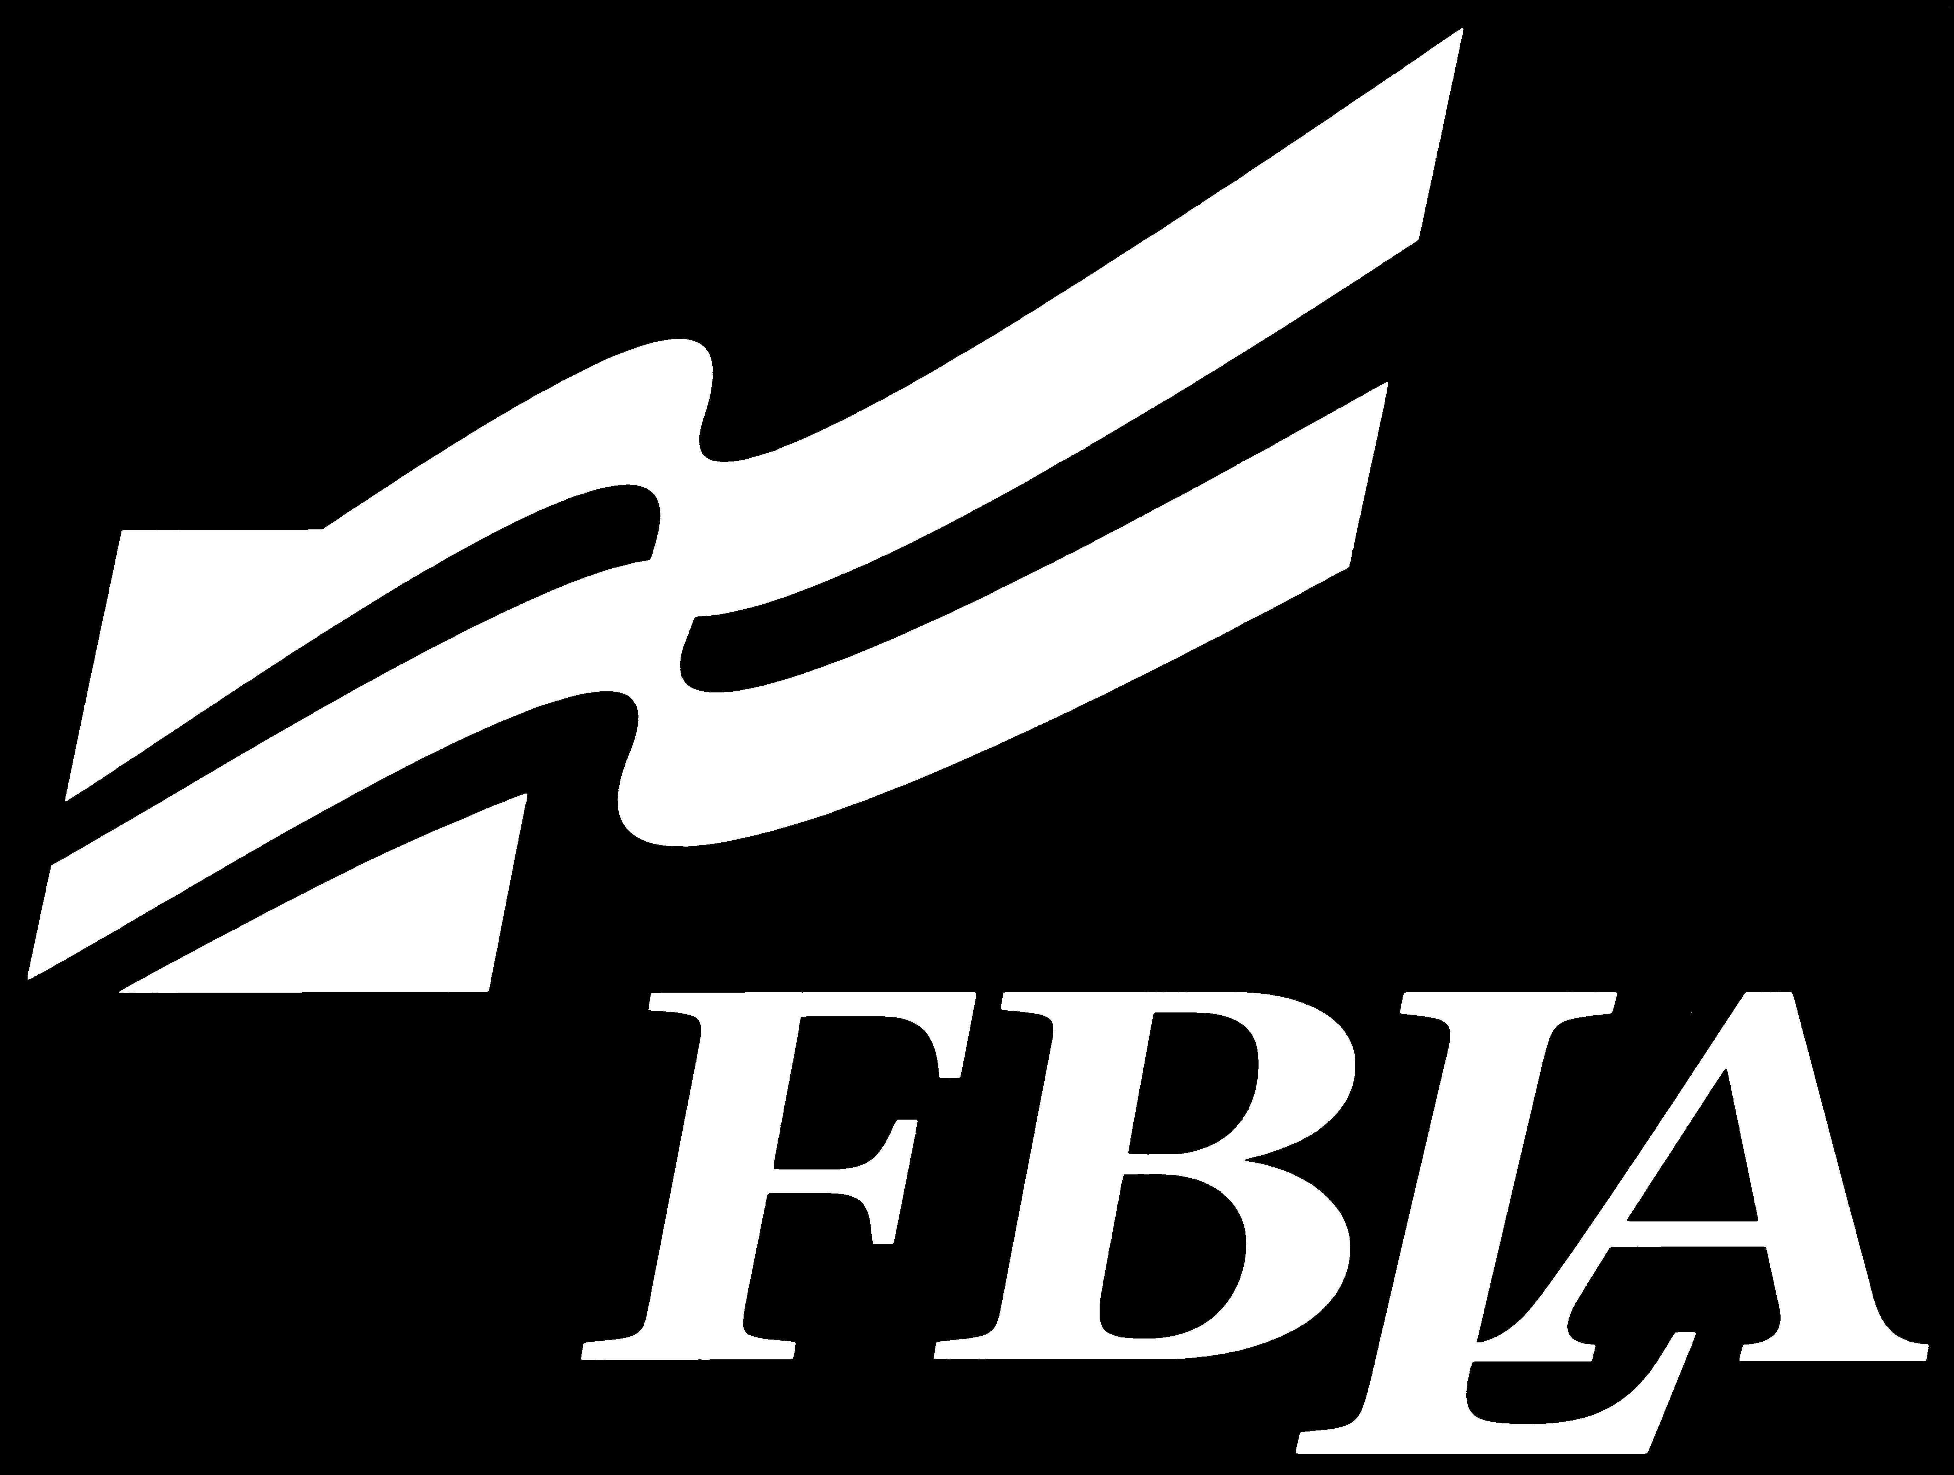

# Conference Forms

The forms you will need to register your chapter for the District Fall Leadership Conference and

District Spring Leadership Conference are contained in this chapter. These forms include:

AAA Eligibility Certificate

Agreement Form

Competitive Event Entry Form

Conduct Rules and Dress Code

Largest Chapter Membership–Market Share

Officer Application

Permission Slip

Registration Form

Special Needs Form

**DO NOT USE THE ORIGINAL FORMS IN THIS HANDBOOK–MAKE A COPY TO USE!**

## Agreement Form

“I have read the conditions of attendance or participation at the FBLA-Middle School/Junior High District Conference, understand them, and agree to refrain from any infraction of these rules and conditions. I understand an infraction of the conduct rules may result in the forfeiture of all individual rights and privileges. I further understand that serious infractions could result in my being sent home. I further agree to attend all meetings of the conference.”

**Delegates Signatures:**

|  |  |
| --- | --- |
| 1. | 15. |
| 2. | 16. |
| 3. | 17. |
| 4. | 18. |
| 5. | 19. |
| 6. | 20. |
| 7. | 21. |
| 8. | 22. |
| 9. | 23. |
| 10. | 24. |
| 11. | 25. |
| 12. | 26. |
| 13. | 27. |
| 14. | 28. |

**\*Attach additional sheets if necessary**

**Approved by:**

Signature of School Superintendent or Principal

Signature of FBLA Chapter Adviser

Name of Local Chapter

**NOTE: Serious infraction of conduct rules could result in**

**parents and/or school official being notified.**

## Conduct Rules and Dress Code

**FBLA-Middle School**

Local chapter advisers will be responsible for the conduct of their students attending all activities.

Advisers are to be available to handle disturbances and accept responsibility for checking student activities.

Advisers should explain student regulations and the reasons for these regulations to all members attending the activity. Members must understand that infractions of the rules of conduct could result in forfeiture of all individual rights and privileges.

Dress Code:

Young Men–dress slacks (no denim of any color), dress shirt, tie and dress shoes (athletic or tennis shoes are not appropriate).

Young women–business suit, appropriate dress, or professional pants suit. Outfits of denim are not allowed. Shoes for women must be dress shoes.

Students must adhere to the dress code stated in the Chapter Management Handbook in the Organization and By-laws tab.

No member shall leave the meeting location unless permission has been received from the adviser. Members must keep their advisers informed of their whereabouts and activities at all times.

No member shall register or attend the conference without having a local adviser registered and present.

There shall be no defacing of public property–any damages to property or furnishings at the location must be paid for by the individual responsible, the local chapter, or the school. Do not remove any property from the premises.

No alcoholic beverages or narcotics in any form shall be possessed by members at any time, under any circumstances. Members are prohibited from smoking at conferences.

Members shall attend all general sessions and activities.

## District Officer Application

**FBLA**- **Middle School**

**See your District Coordinator for current form.**

**This will be turned in before the Spring Conference.**

## Permission Slip

## FBLA-Middle School

Student’s Name _________________________________ Date

This is to state that my son/daughter named above has my permission to attend the FBLA-Middle School district conference, relieving the individual advisers, school, and Department of Career Education of any responsibility which does not come under the term “reasonable,” and further agree that the authority to control and enforce the listed rules and regulations which have been deemed advisable and reasonable for all students attending this activity is given to the adviser.

Signature of Parent/Guardian Home Phone

Cell Phone Business Phone

## District Conference Leadership Registration

**FBLA-MIDDLE SCHOOL**

Registration instructions for each conference will be distributed by district coordinator.

Registration is done in FBLA Connect.

## Arkansas Activities Association

3920 Richards Road

North Little Rock, AR 72117

Office: (501) 955-2500 Fax: (501) 955-2600

**Certificate of Eligibility for Non-Athletics**

We certify that we are familiar with the rules governing the eligibility of students under the Constitution and Bylaws of this Association, that we have personally checked this list, and that the persons or organization named have complied in all respects with the requirements for eligibility under the rules and are entitled to represent this school in the activities during the _____________ semester of ___________.

1st or 2nd Year

Respectfully,

Superintendent or Principal

Sponsor or Director

School Address

**Please attach this form to each list of names or application and forward to your district coordinator.**

**DO NOT SEND TO ARKANSAS ACTIVITIES ASSOCIATION**

**NOTE: This form must be submitted to be eligible to compete.**

## Largest Chapter Membership–Market Share

## FBLA Middle-Level

## ENTRY FORM

SCHOOL

Number of FBLA members who have paid local, state and national dues by January 1.

**LIST GRADE LEVELS DURING WHICH STUDENTS MAY BELONG TO FBLA**

|  |  |  |
| --- | --- | --- |
| **Grade Level** | **Student Body**  **Enrollment\*** | **Number of**  **FBLA Members** |
| 5th Grade |  |  |
| 6th Grade |  |  |
| 7th Grade |  |  |
| 8th Grade |  |  |
| 9th Grade |  |  |
| **TOTALS** |  |  |
| **PERCENTAGE OF FBLA MEMBERS OF THE ELIGIBLE STUDENT BODY** | |  |

**\*Total** student body enrollment for each grade level must be used.

**I CERTIFY THAT THE ABOVE INFORMATION IS CORRECT:**

**Chapter Adviser**

## Special Needs Form

**FBLA-Middle School**

If you have a student that requires special needs at the FBLA District Spring Leadership Conference, please state the need(s) below and return this form to the district coordinator.

School

Adviser

Phone ______________________ Adviser’s E-Mail

Name of Student

Event Entered

Special needs required